Monoclonal Antibody Cross-Reactivity between Swine Influenza Hemagglutinins

Amanda Skarlupka’s Data Analysis Project

Amanda Skarlupka

2019-11-29

# Summary/Abstract

Although a vaccine for influenza exists, the efficacy and efficiency of the vaccine is very low and needs to be administered annually. Neutralizing antibodies are elicited from vaccination and are recalled during an infection. The Ross Lab at the CVI has developed a P1 hemagglutinin (HA) Computationally Optimized Broadly Reactive Antigens (COBRA) created with swine and human isolated H1 influenza HA sequences. Monoclonal antibodies specific for P1 HA were individually more broadly reactive against human isolated influenza than wild-type HA specific monoclonals. These monoclonals were tested for neutralizing activity against the swine isolated viruses. The P1 monoclonals and A/California/07/2009 monoclonals both reacted against swine viruses.

# Introduction

The majority of the surface of the influenza virion is composed of two glycoproteins: the hemaglutinin (HA) and the neuraminidase (NA). Upon vaccination the host responsed by producing neurtralizing antibodies targeting these surface proteins. Due to the high variablity and mutability of the HA, the influenza virus is able to undergo antigenic drift and evade vaccine induced protection. In the Ross lab, a cross-reactive HA protein vaccine has been developed. This computational HA (P1 COBRA HA) contains a broader set of antibody epitopes than wild-type HAs. To further investigate the renterence between the epitopes displayed on the P1 and the wild-type A/California/07/2009 (CA/09) HA, monoclonal antibodies raised against each antigen were purified and are currently undergoing characterization. It was found that the P1-specific antibodies bound to a wider range of human isolated influenza viruses, whereas the CA/09 antibodies were more narrow. However, influenza is also isolated from swine hosts, and swine influenza sequences were used in the design of the P1 COBRA HA immunogen. Therefore, the P1-specific antibodies may bind to more wild-type swine influenza HAs than CA/09 antibodies. The impact of a cross-species influenza vaccine is useful for animal-workers, as well as, prevention of a future pandemic.

The data contains 1.) the minimum hemagglutination inhibtion concentration of each purified monoclonal antibody from CA/09 or P1 COBRA, 2.) the hemagglutination inhibtion titer of the polyclonal sera from the mice that the monoclonal antibodies were purified from, 3.) the tested HAs are different swine influenza H1 viruses. There were nineteen different swine viruses. There were tweleve P1 Mabs, eighteen CA/09 Mabs, polyclonal sera from six CA/09 mice, and polyclonal sera from ten P1 mice.

I have generated the minimum inhibitory concentration data and the HAI titer data. The other data is classification data. The Dr. Sautto has determined the binding locations of the antibodies and whether they compete for similar epitope regions. Furthermore, the tested swine viruses are categorized into different genetic lineages.

## Questions/Hypotheses to be addressed

Monoclonal antibodies raised against P1 COBRA HA immunogen show a wider-breadth hemagglutinin inhibtion among different influenza viruses than monoclonal antibodies raised against CA/09 HA. Furthermore, the minimum hemagglutin inhibition concentration of the antibodies is less than those elicited by CA/09. We would like to investigate if there are any discernable differences between the inhibtion of P1 antibodies and CA/09 antibodies. Do the P1 monoclonals have a wider breadth of binding to swine influenza? Are the responses different enough that we can use that data to predict based on the observed outcome if the antibody used was a P1 or a CA/09 antibody? We believe that the P1 monoclonals will have a binding to the swine viruses at least equivalent to the CA/09 monoclonals.

# Material and Methods

#### Monoclonal Antibody Production

The monoclonal antibodies used for the assays are described in 1.

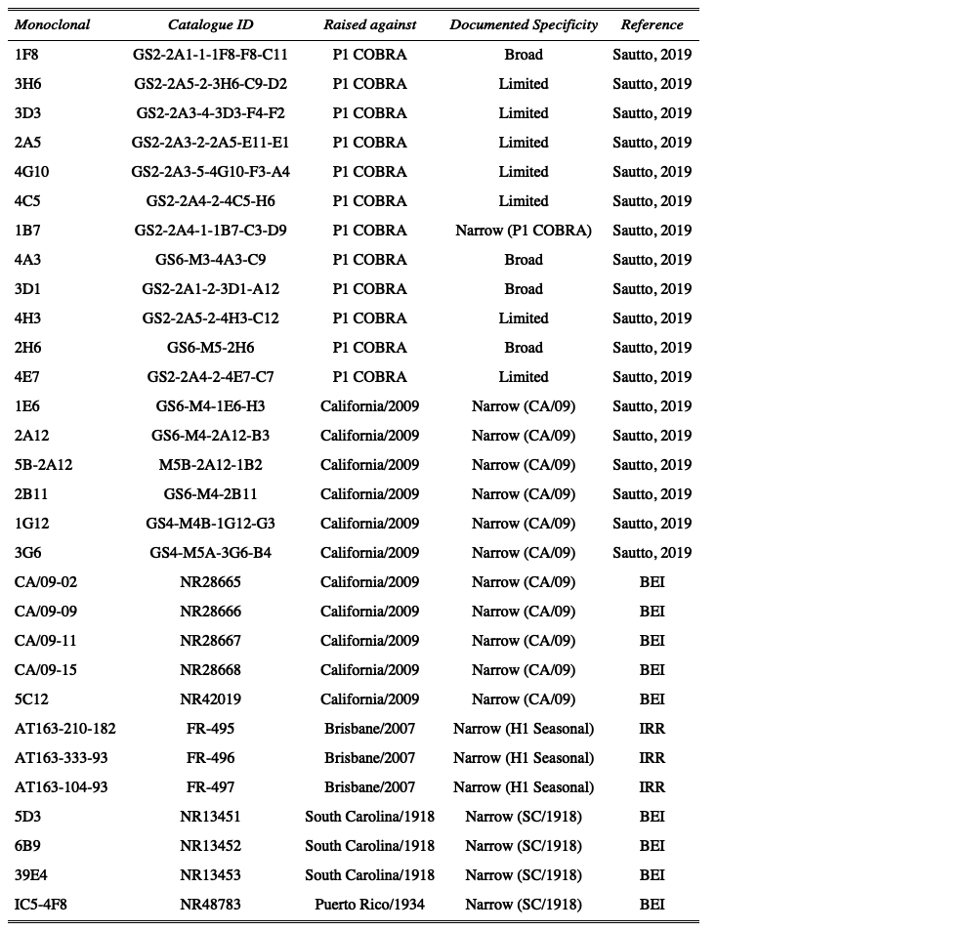

Figure 1: Table1.

#### Viruses and HA antigens

H1 viruses were obtained through the Influenza Reagents Resource (IRR), BEI Resources, the Centers for Disease Control (CDC), Sanofi-Pasteur, or the Tompkins Laboratory. Viruses were passaged once in the same growth conditions as they were received or as per the instructions provided by the WHO or the University of Minnesota, in either embryonated chicken eggs or Madin-Darby canine kidney (MDCK) cell culture. Virus lots were aliquoted for single-use applications and stored at -80°C. Hemagglutination titer of the frozen aliquots was determined with turkey RBCs.

The classification of the swine HA was determined using the Swine H1 Clade Classification Tool (<http://www.fludb.org>) and infers both the global (Anderson et al., 2016) and US (Anderson et al., 2015, 2013) swine H1 clade classification from the HA nucleotide sequence. When available, virus was used for HAI assays, otherwise virus-like particles (VLP) were used. The protein accession numbers for the HA amino acid sequences used for virus-like particle production are provided. The CDS of the wild-type HAs were codon optimized for expression in human cells.

Swine wild-type HAs were chosen to be representative of the different lineages and clades described in 2.

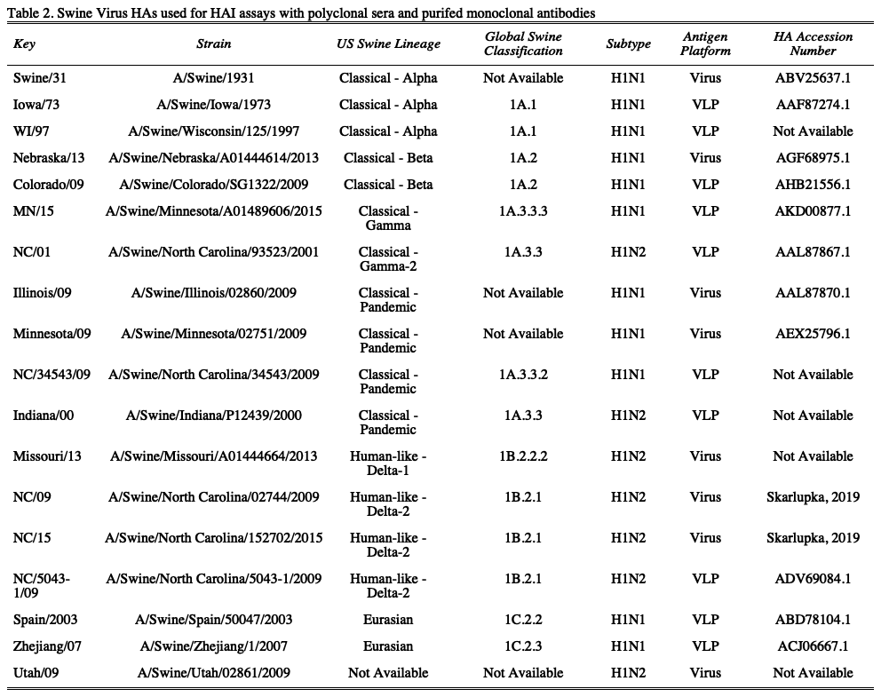

Figure 2: resulttable2.

#### Virus-like Particle (VLP) preparation

Human embryonic kidney 293T (HEK-293T) cells (1 x 10^6 cells total) were transiently transfected with 1 μg DNA of each of the three pTR600 mammalian expression vectors (Skarlupka et al., 2019) one of each expressing the influenza neuraminidase (A/Mallard/Alberta/24/2001; H7N3), the HIV p55 Gag sequence, and one of the various H1 wild-type hemagglutinins. Following 72 h of incubation at 37°C in serum free medium, transiently transfected cell supernatent was collected, centrifuged to remove cellular debris, and filtered through a 0.22 μm pore membrane. Virus-like particles (VLPs) were purified and sedimented by ultracentrifugation on a 20% glycerol cushion at 135,000 x g for 4 h at 4°C. VLPs were resuspended in phosphate buffered saline (PBS), and total protein concentration was determined with the Micro BCA Protein Assay Reagent kit (Pierce Biotechnology, Rockford, IL, USA). Hemagglutination activity (HA) of each preparation of VLP was determined by serially diluting volumes of VLPs and adding equal volume 0.8% turkey red blood cells (RBCs) (Lampire Biologicals, Pipersville, PA, USA) suspended in PBS to a V-bottom 96-well plate with a 30 min incubation at room temperature (RT). Prepared RBCs were stored at 4°C and used within 72 h. The highest dilution of VLP with full agglutination of RBCs was considered the endpoint HA titer.

#### Hemagglutination inhibition (HAI) assay

The hemagglutination inhibition (HAI) assay assessed functional antibodies specific to the HA able to inhibit agglutination of turkey erythrocytes. The protocol is adapted from the WHO laboratory influenza surveillance manual. HAIs were conducted with either polyclonal mouse sera or purified monoclonal antibodies. Polyclonal sera were treated with receptor-destroying enzyme (RDE) (Denka Seiken, Co., Japan) prior to being tested to inactivate nonspecific inhibitors. Briefly, three parts RDE were added to one part sera and incubated overnight at 37°C. RDE was inactivated by incubation at 56°C for ∼30 min. After heat treatment, six parts PBS were added to the RDE-treated sera. Purified monoclonal antibodies were adjusted to a concentration of 20 μg/ml in PBS.

RDE-treated and monoclonal antibodies were added in 50 μl to a V-bottom microtiter plate and were two-fold serially diluted across in PBS. An equal volume, 25 μl, of each virus (or VLP where applicable), adjusted to approximately 8 hemagglutination units (HAU)/50 μl, was added to all wells except for the last column which received 25 μl of PBS. The plates were covered and incubated at RT for 20 min. Then, 50 μl of 0.8% turkey red blood cells were added to each well. The plates were mixed by agitation and covered, and the RBCs were allowed to settle for 30 min at RT. The polyclonal sera HAI titer was determined by the reciprocal dilution of the last well that contained non-agglutinated RBCs. The monoclonal minimum agglutination concentration was determined by the dilution of the last well that contained non-agglutinated RBCs multiplied by the starting concentration of 20 μg/ml. Negative controls were included for each plate.All mice were negative (HAI < 1:10) for preexisting antibodies to currently circulating human and swine influenza viruses prior to vaccination.

#### Statistical Analysis

The limit of detection for the polyclonal sera HAI was 1:10, and 1:5 was used for the statistical analysis of samples below that. The limit of detection for the monoclonal antibody HAI was 10 ug/ml. Samples below that limit were defined as 20ug/ml for statistical analysis. The log2 geometric mean was calculated from the HAI titers of the polyclonal sera and monoclonal antibody concentrations.

# Results

### Data cleaning and Transformations

The data was imported from the raw excel data file along with the antigen and antibody keys.

Due to a limited supply of polyclonal sera, the HA inhibition was only determined for a representative swine virus from each lineage and clade. The monoclonal antibody HAI antigen panel included a wider range of antigens. Therefore, the HAs not included in the sera HAIs were removed from the sera analysis.

Variables were created based on the raw HAI titers for both the polyclonal sera and monoclonal antibodies. The polyclonal sera titer and monoclonal antibody conentration was transformed by log base 2. Furthermore, the monoclonal antibody dilution factor was determined by dividing 20ug/ml by the endpoint agglutination concentration.

## Univariate analysis

### Polyclonal sera analysis

Similar to the previous study between the COBRA antigens and HAI titers to swine viruses (Skarlupka et al., 2019), the P1 and CA/09 sera had differential reactions to the groups of different swine viruses (Figure 1). There were some viruses that had no HAI titer to such as NC/01, and MN/15. P1 sera had higher responses with respect to the Eurasian lineage viruses and three out of four classsical lineage viruses that exhibited inhibtion.

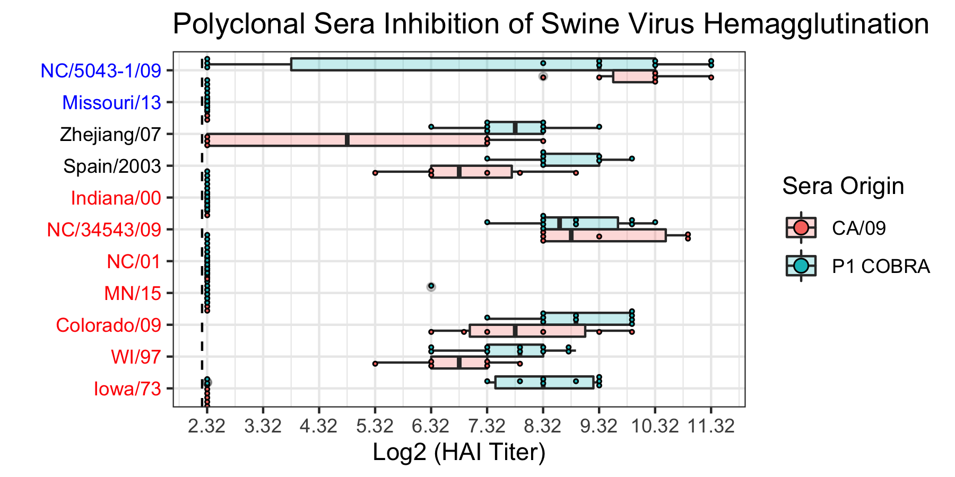

Figure 3: Figure 1. The HA inhibition of swine viruses of polyclonal sera of mice sub-lethally challenged with either A/California/07/2009 (CA/09) or P1 COBRA viruses. The limit of detection was 2.32 log2(HAI titer). The swine virus panel included representatives from the classical (red), Eurasian (black), and human seasonal-like (blue) clades.

### A/California/07/2009 Monoclonal Analysis

Monoclonal antibodies isolated from the mice that the same polyclonal sera was taken from, in addition to previously isolated wild-type influenza monoclonals, were tested for HAI titers against the swine viruses (Figure 2). The monoclonals were characterized into three groups based on their previously documented HAI reactivity with human-isolated influenza. These groups included inhibtion of 1.) only 1918 pandemic-like, 2.) only CA/09 pandemic-like, or 3.) only human-seasonal viruses. The monoclonals that had reactivity against the human-seasonal viruses had not reactivity against the swine viruses. The 1918-specific monoclonals were reactive against 8 of the 18 swine viruses. All of these monoclonals reacted against the same viruses with similar titer to each other. The viruses in this group were either from the Eurasian or classical swine lineages with one outlier in the human seasonal-like lineage. The CA/09 specific monoclonals had a higher titers and a wider response across more viruses compared to the other two groups. The responses differ in which antibodies recognize which virus, and also in the magnitudes of the responses. These monoclonals still show limited human seasonal-like reactivity though. Therefore, the CA/09 monoclonals are to be investigated further. 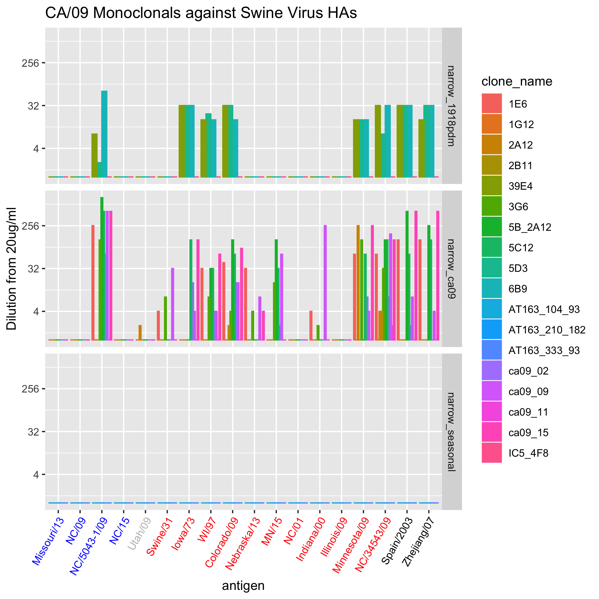

The CA/09-raised antibodies have a varied response based on individual monoclonals (Figure 3.) The responses between antibodies differed. The monoclonals 2A12, 2B11, 1G12 and CA09-11 had limited responses to the swine viruses. The 1G12 had no reactivity at all, and 2A12 was interesting in the manner that it recognized A/swine/Utah/09 which no other antibody recognized. The other monoclonals had varied responses across the swine influenza viruses.

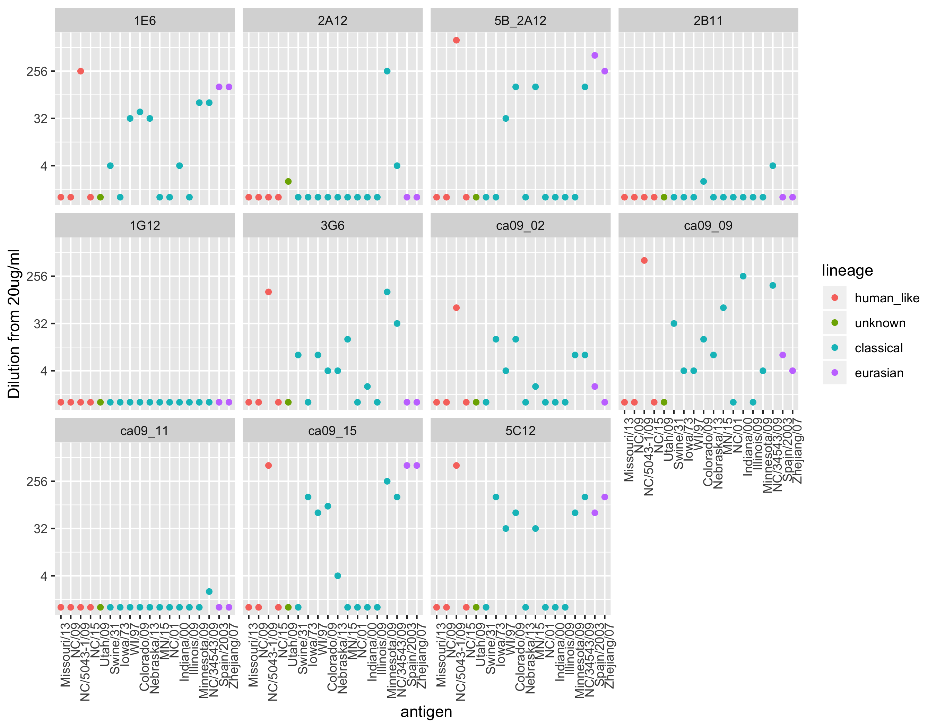

Figure 5: Figure 3. Individual CA/09-raised HAI responses to swine influenza viruses. The dilution of the monoclonal antibody that had the highest HA inhibition depicted.

### P1 Monoclonal Analysis

Monoclonal antibodies isolated from the P1 mice were tested for HAI titers against the swine viruses (Figure 4). The monoclonals were characterized into three groups based on their previously documented HAI reactivity with human-isolated influenza. These groups included inhibtion of 1.) broadly-reactive, 2.) narrowly-reactive, or 3.) only P1-reactive. The P1 specific monoclonal had that previously only reacted against P1 and no human virus had reactivity against the swine viruses. Therefore, this is a major finding - all monoclonal antibodies that had HAI activity for P1 were found to be broadly reactive either against human or swine isolated influenza. The monoclonal antibodies that were broadly reactive against human influenza were less broadly reactive to swine influenza. Whereas the opposite was seen with the narrowly reactive antibodies, as they were broadly-reactive against the swine influenza viruses. There was a wider variety of influenza viruses recogized with a variety of differing magnitudes. Futhermore, the P1 monoclonal antibodies recognized one more human seasonal-like virus (A/Swine/NC/09).

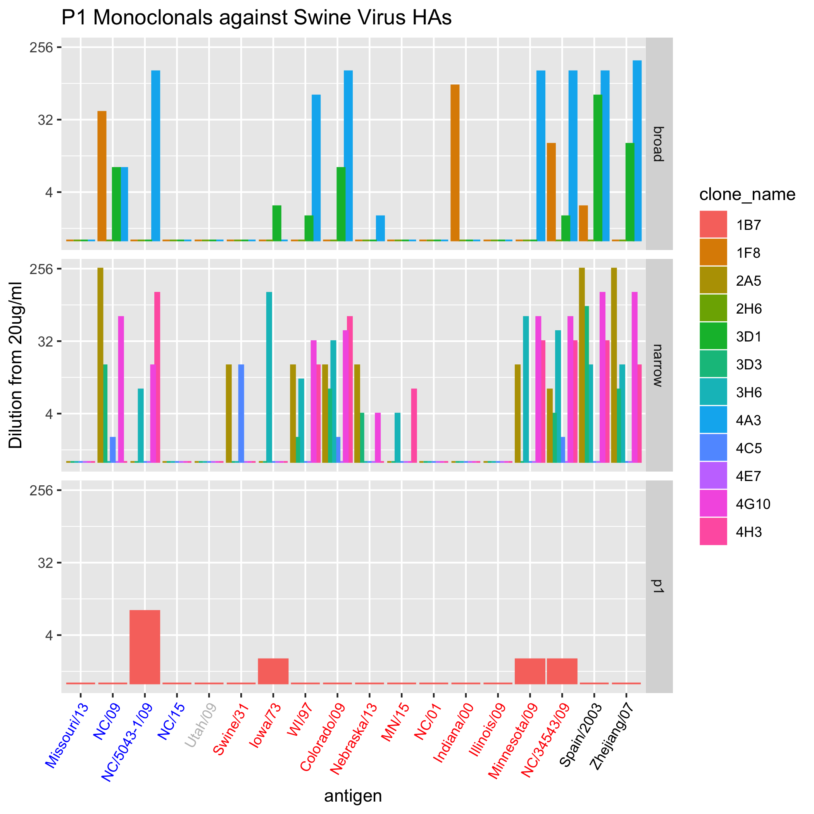

Figure 6: Figure 4. P1-raised monoclonal antibodies and their inhibition of swine influenza HAs separated by human virus reactivity. Classical lineage = red; Eurasian lineage = black; Human seasonal-like lineage = blue.

The P1-raised antibodies also had varied responses that were monoclonal specific (Figure 5.). Two monoclonals, 2H6 and 4E7, and no response to any virus. Whereas, 1B7, 1F8, and 4C5 had a limited response, inihibiting a maximum of 4 viruses. The other monoclonal antibodies had a variety of different inhibition profiles.

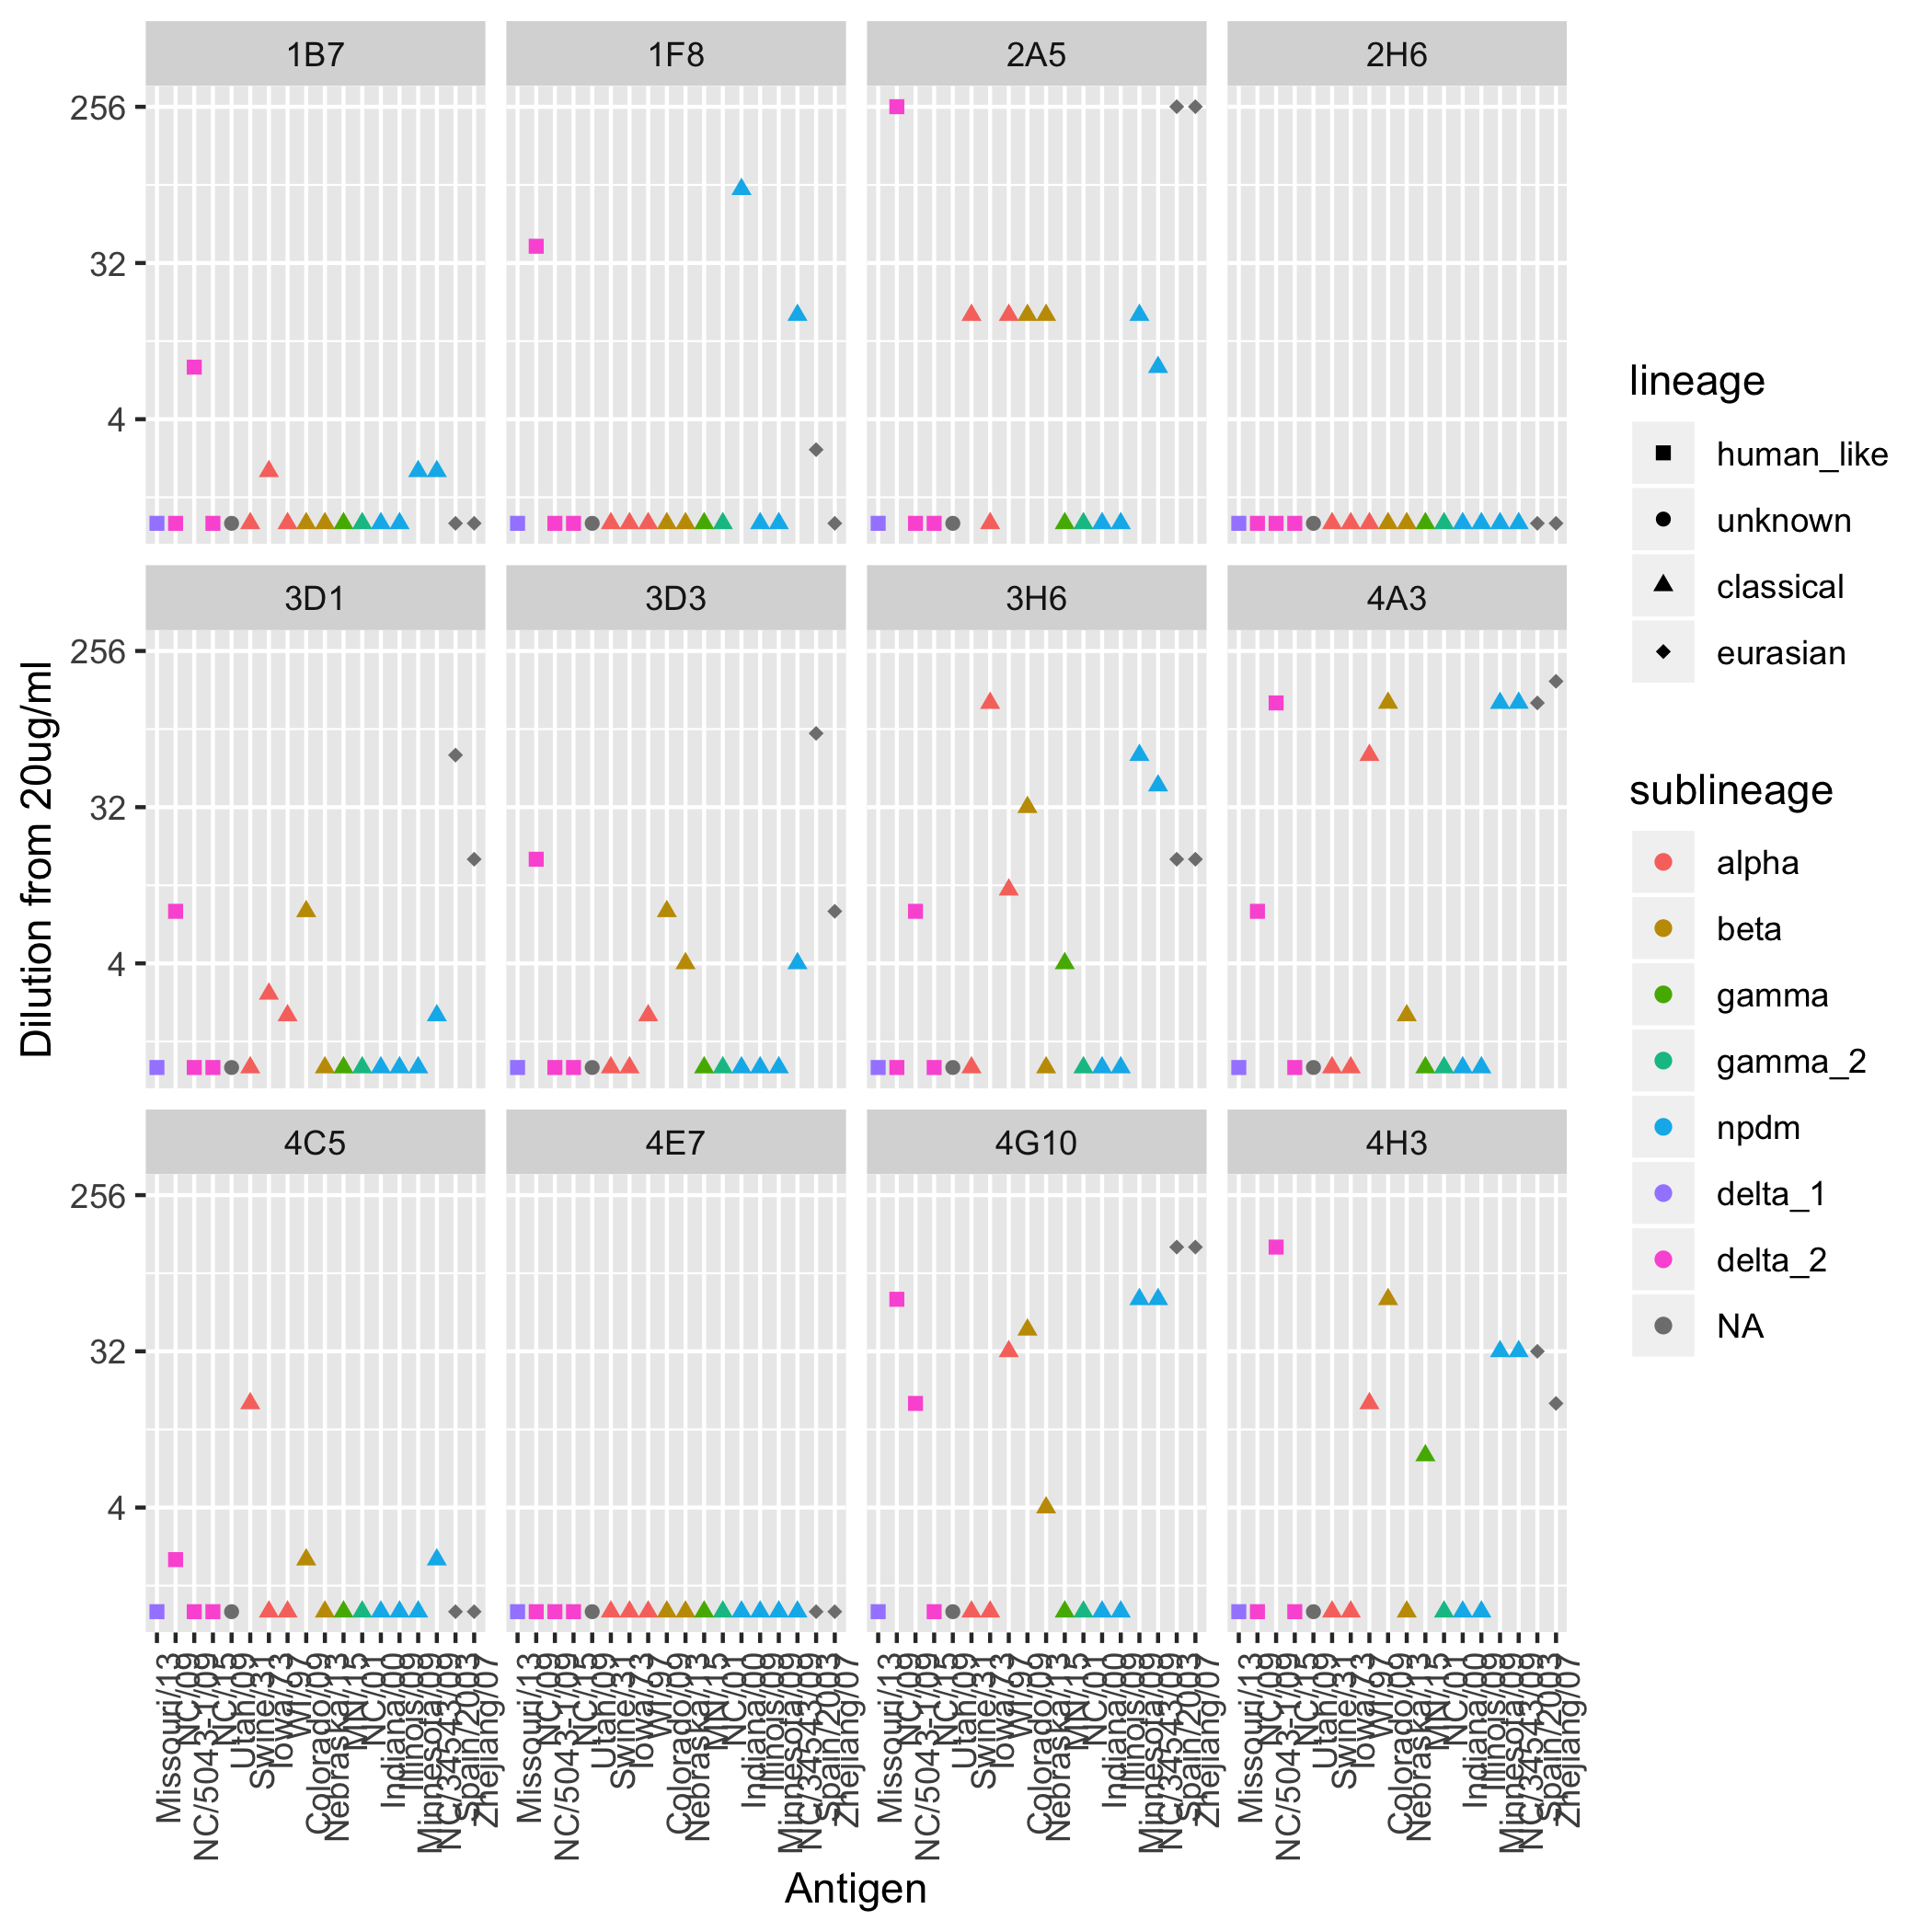

Figure 7: Figure 5. Individual P1-raised HAI responses to swine influenza viruses. The dilution of the monoclonal antibody that had the highest HA inhibition observered is located on the y-axis.

### Summary Monoclonal Analysis

Some of the antigens never responded to any monoclonal antibody. These viruses included A/Swine/Missouri/13, A/Swine/NorthCarolina/2015, and A/Swine/Illinois/2009. These viruses were removed to investigate which virus is being reacted to by the monoclonals more clearly. The wild-type raised antibodies reacted with the Eurasian lineage and the classical viruses (Figure 6.)



Figure 8: Figure 6. The HAI titers of CA/09 specific monoclonal antibodies with the removal of antigens that never responded to any antibody separated by human virus reactivity profile. The radius depicts increasing HAI titer.

The P1-raised antibodies again showed reactivity to the classical and Eurasian viruses (Figure 7.).



Figure 9: Figure 7. The HAI titers of P1 specific monoclonal antibodies with the removal of antigens that never responded to any antibody which are separated by human virus reactivity profile. The radius depicts increasing HAI titer.

## Virus Inhibition

After determining that the monoclonal antibodies do recognize the swine viruses. The differences between the monoclonals were characterized. Comparing the total number of viruses that the different monoclonals inhibit the CA/09 monoclonals shows a wider range of viruses per antibody (Figure 8). Inhibition was defined as a concentration of less than 20 ug/ml needed to induce HAI activity (the limit of detection). The CA09-09 monoclonal inhibited the most viruses (tweleve viruses). In addition, of the monoclonals that had activity, the CA09-11 antibody inhibited the least amount - one virus. The SC/1918-raised antibodies all recognized the same amount (eight) and the PR/34 antibody did not recongize any (data not shown). The P1 monoclonals recognized between four and nine viruses. The variation between the P1 monoclonals seems to be smaller than the variation from the CA/09 monoclonals.

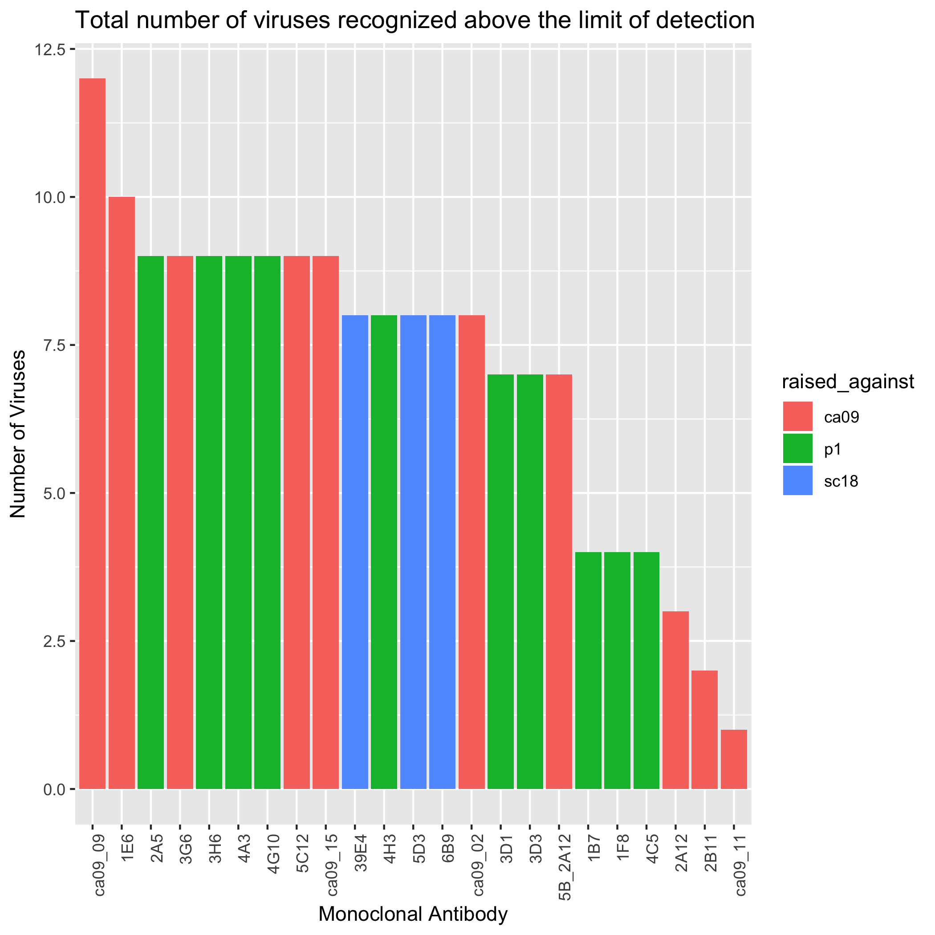

Figure 10: Figure 8. The total number of swine viruses recognized by individual monoclonal antibodies.

## Bivariate analysis of P1 monoclonals compared to CA/09 monoclonals

To statistically investigate the data, it was separated into two different datasets. The first included all of the variables associated with the swine viruses and the antibodies (Figure 9). The second included all of the monoclonals and their matching inhibitory concentration for each swine virus (Figure 10).

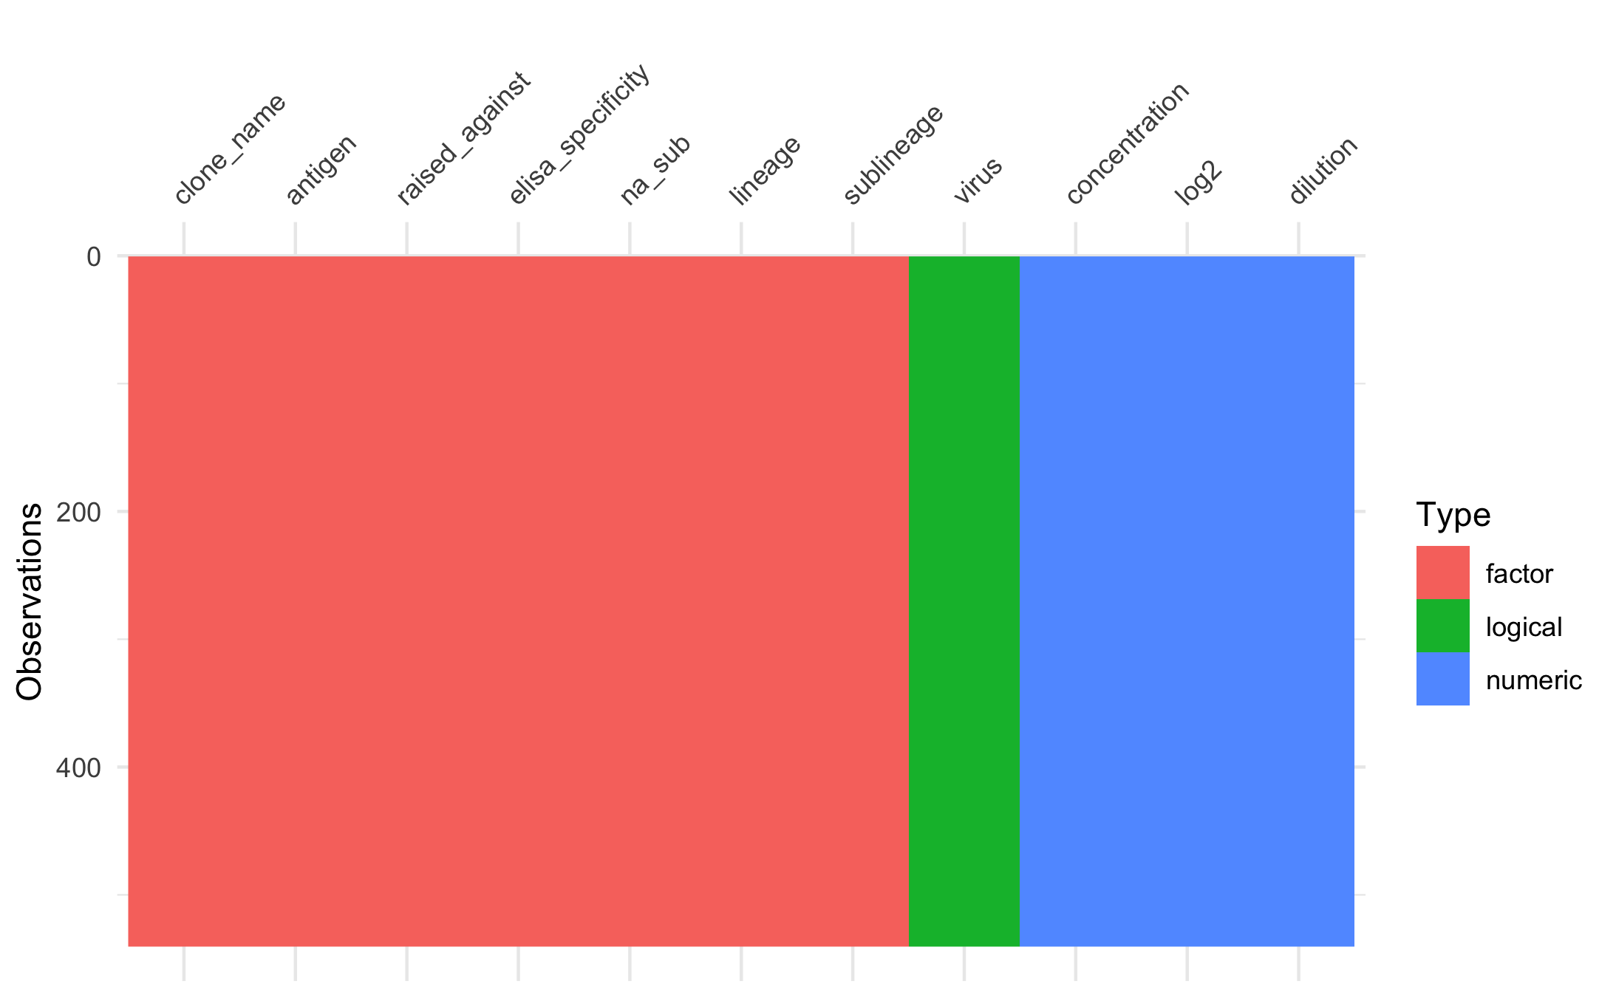

Figure 11: Figure 9. Variables, their class, and total number of observations for dataset one.

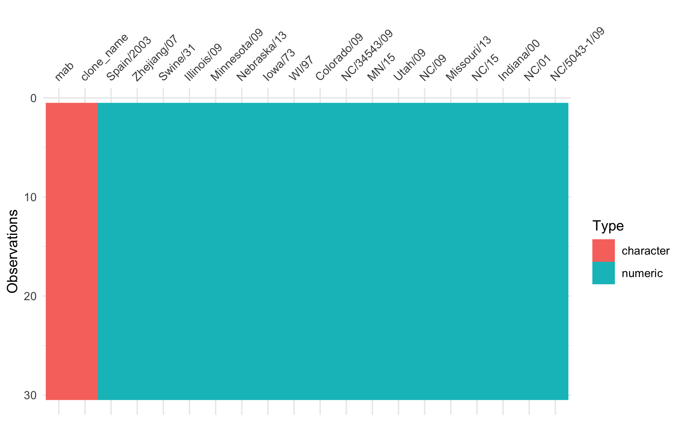

Figure 12: Figure 10. Variables, their class, and total number of observations for dataset two

The outcome variable is the origin of the monoclonal. It is of interest to determine if from the characteristics of the viruses the origin of the monoclonal can be determined. Therefore the characteristics of the outcome variable is depicted in Figure 11. The outcome variable is about equally weighted between the two options (P1 and CA/09).

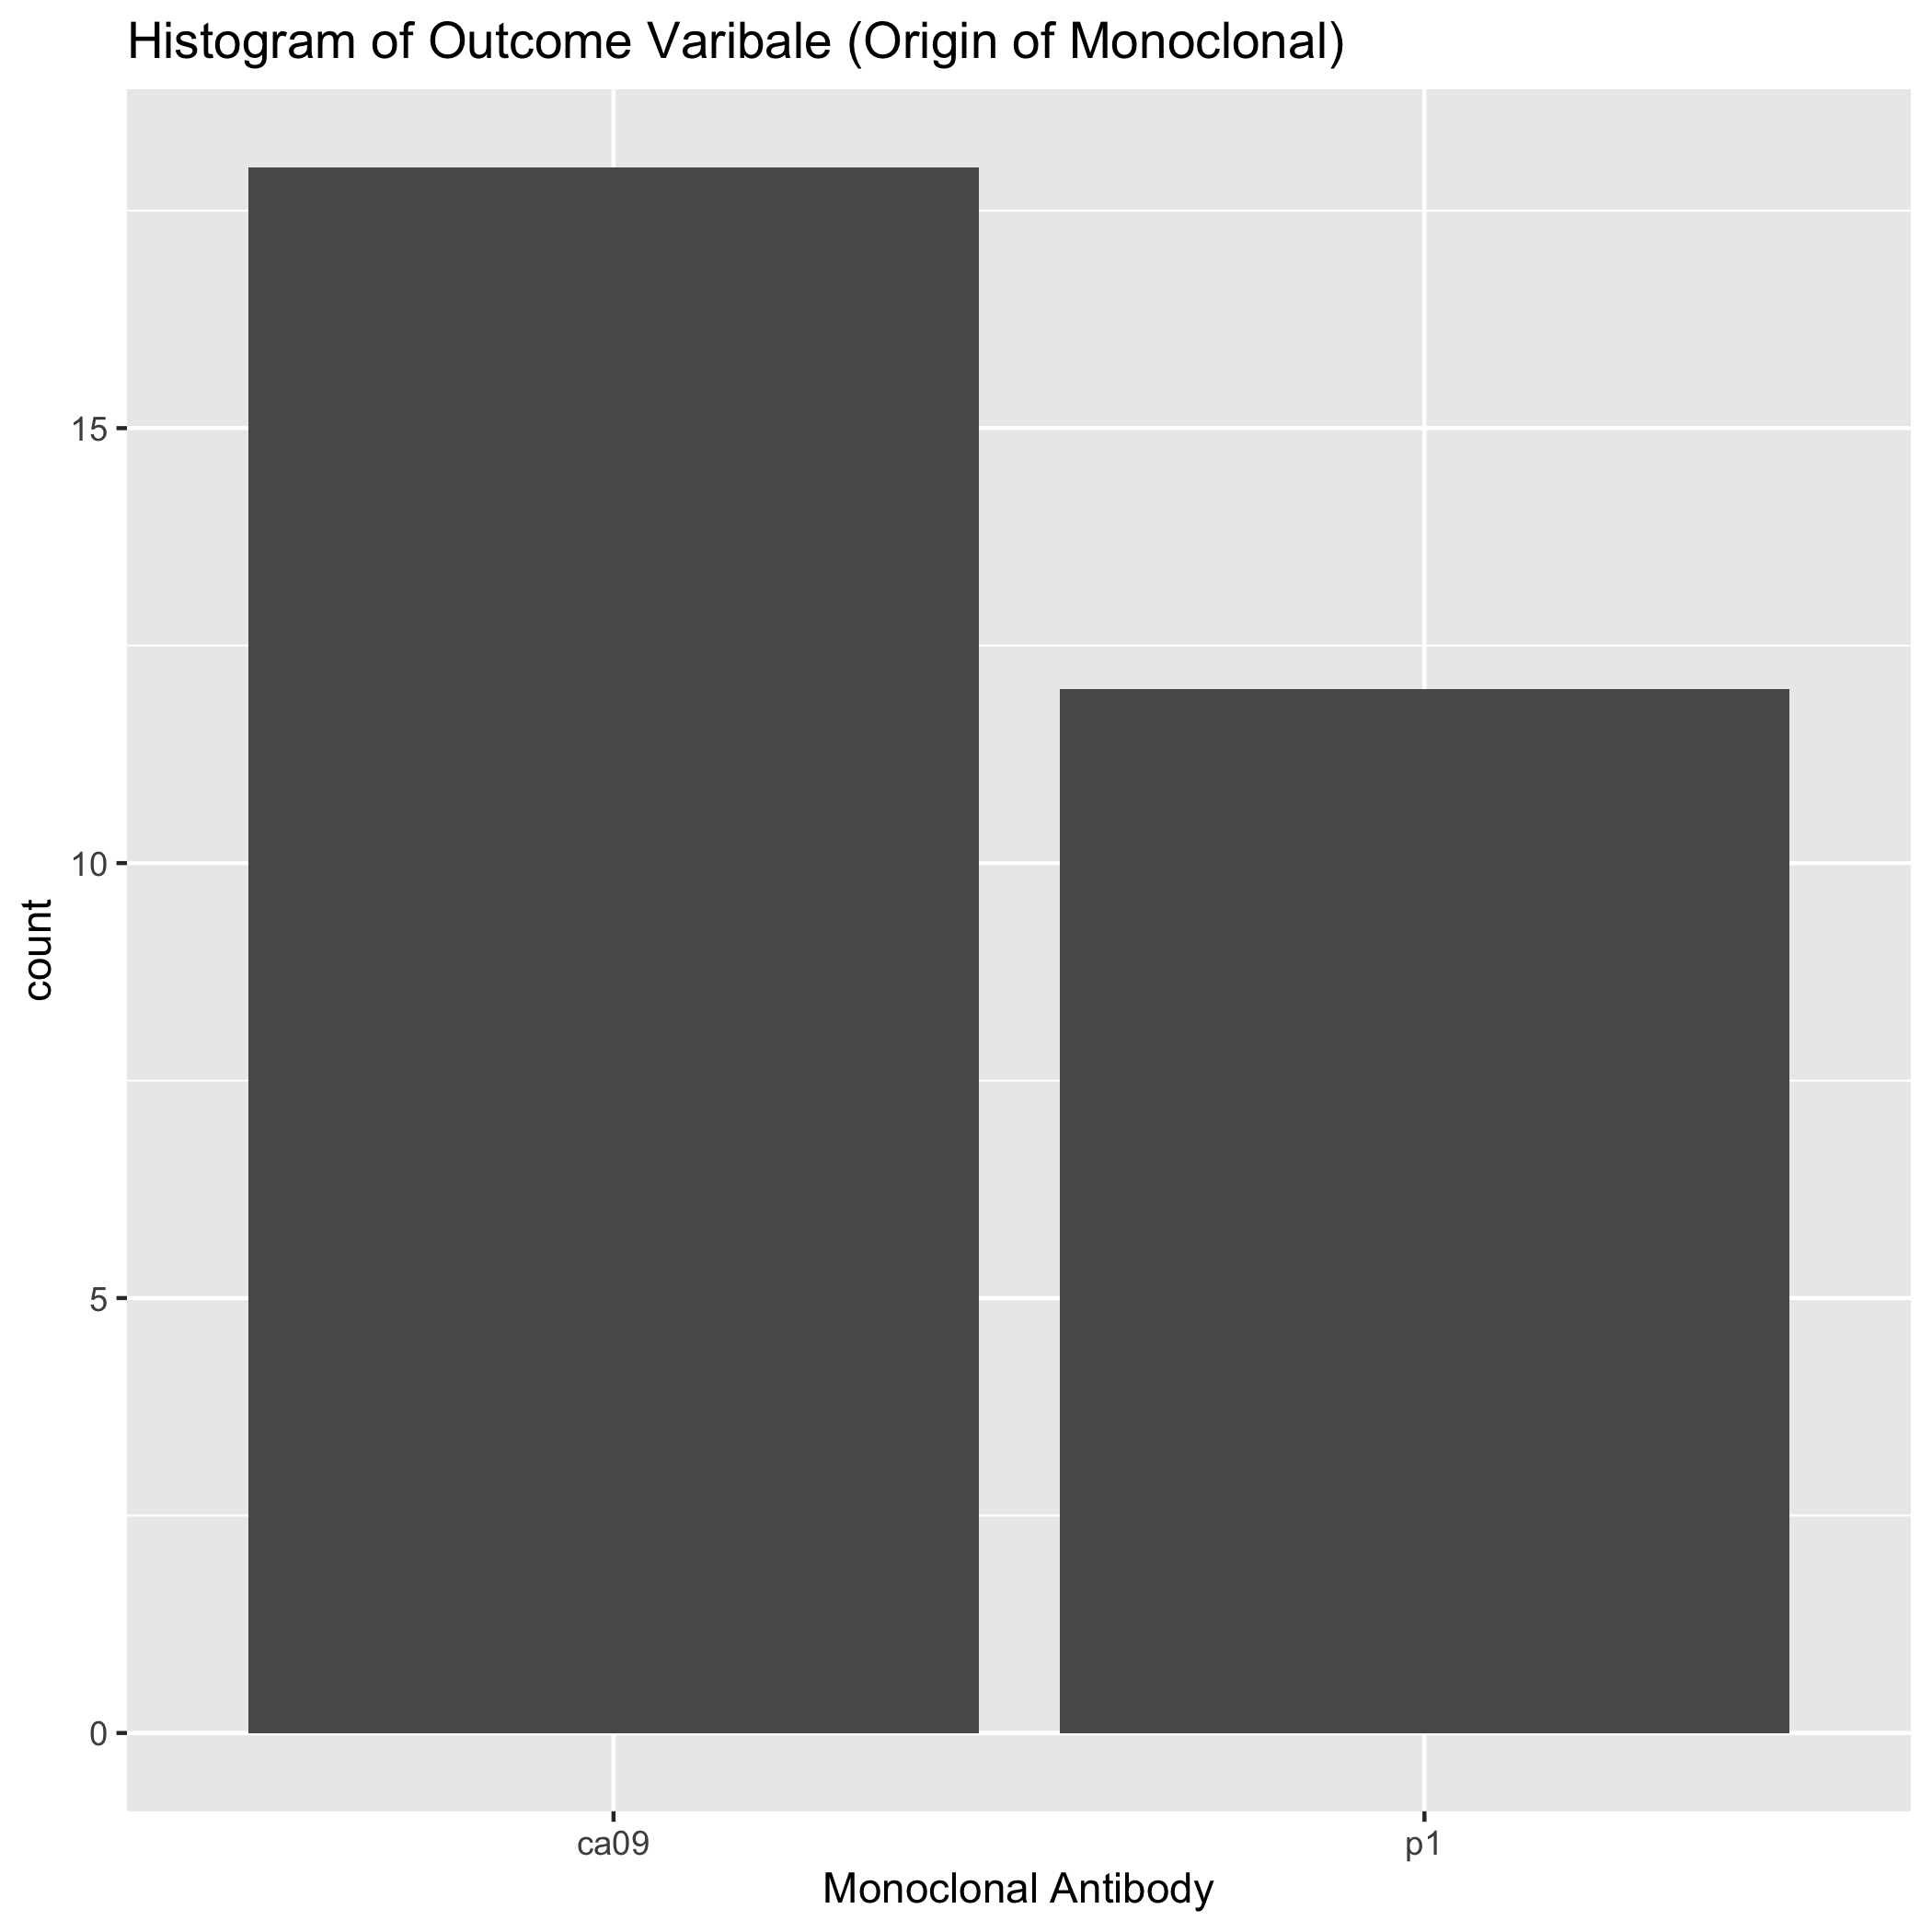 The minimum inhibitory concentration of the two outcome monoclonals were compared to each other for the different swine viruses (Figure 12). Many of the responses were the same.

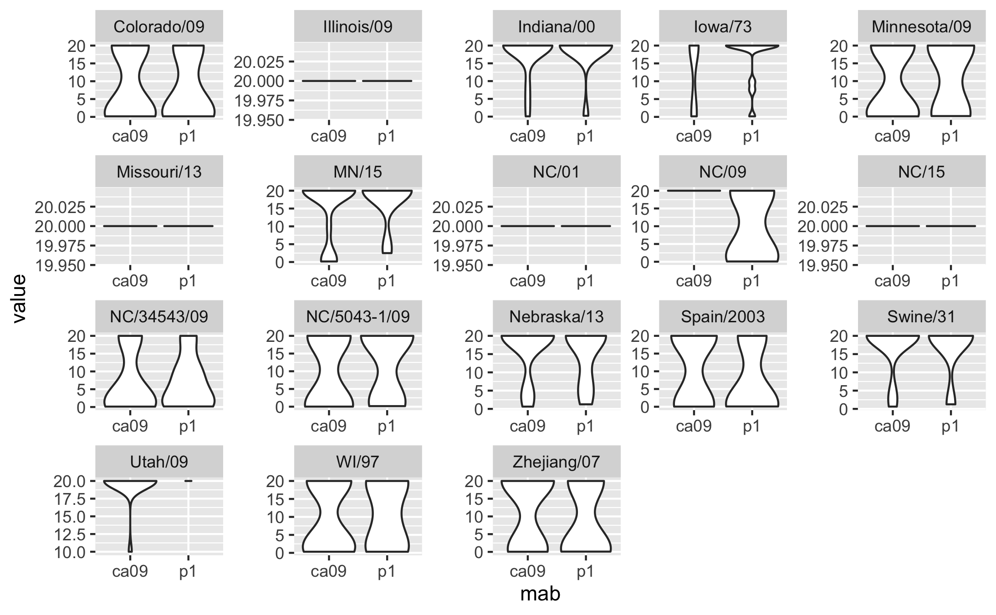

Figure 14: Figure 12. classical (red), Eurasian (black), and human-like (blue) clades.

The CA/09, P1, Bris/07, PR/34, and SC/18 titers were tested individually to confirm the assumption that the data is normally distributed in order to run a t-test between the data sets. Two of the assumptions for an unpaired t-test is that 1.) the data is normally distributed and 2.) the variance between the groups is not significantly different. However, the data failed the Shapiro-wilk test for normality (Table 3 and 4).

##   
## Shapiro-Wilk normality test  
##   
## data: concentration[raised_against == "ca09"]  
## W = 0.64754, p-value < 2.2e-16

##   
## Shapiro-Wilk normality test  
##   
## data: concentration[raised_against == "p1"]  
## W = 0.63063, p-value < 2.2e-16

The dataset failed the first assumption. Therefore, the difference in variance was determined (Table 5). The F-test, when comparing the concentration values, determined that the ratio of variances is equal to one.

##   
## F test to compare two variances  
##   
## data: concentration by raised_against  
## F = 0.96923, num df = 107, denom df = 107, p-value = 0.8719  
## alternative hypothesis: true ratio of variances is not equal to 1  
## 95 percent confidence interval:  
## 0.6621671 1.4186746  
## sample estimates:  
## ratio of variances   
## 0.9692263

The data is not normally distributed, but the concentration data does pass the variance assumption. Therefore, a non-parametric Wilcoxon rank test was used instead of a t-test to determine if the groups are statistically significant (Table 6. According the the Wilcoxon rank sum test, they are not (p-value = 02867).

##   
## Wilcoxon rank sum test with continuity correction  
##   
## data: ca09_conc and p1_conc  
## W = 20292, p-value = 0.2867  
## alternative hypothesis: true location shift is not equal to 0

All of the variables of the titer data set were visualized to determine if there were pre-existing correlations (Figure 13). Some viruses correlated very well with each other (dark red boxes). There were some that had slightly negative correlations (lifht blue), and others that were unable to be correlated (IL/09; MO/13; NC/01; and NC/15).

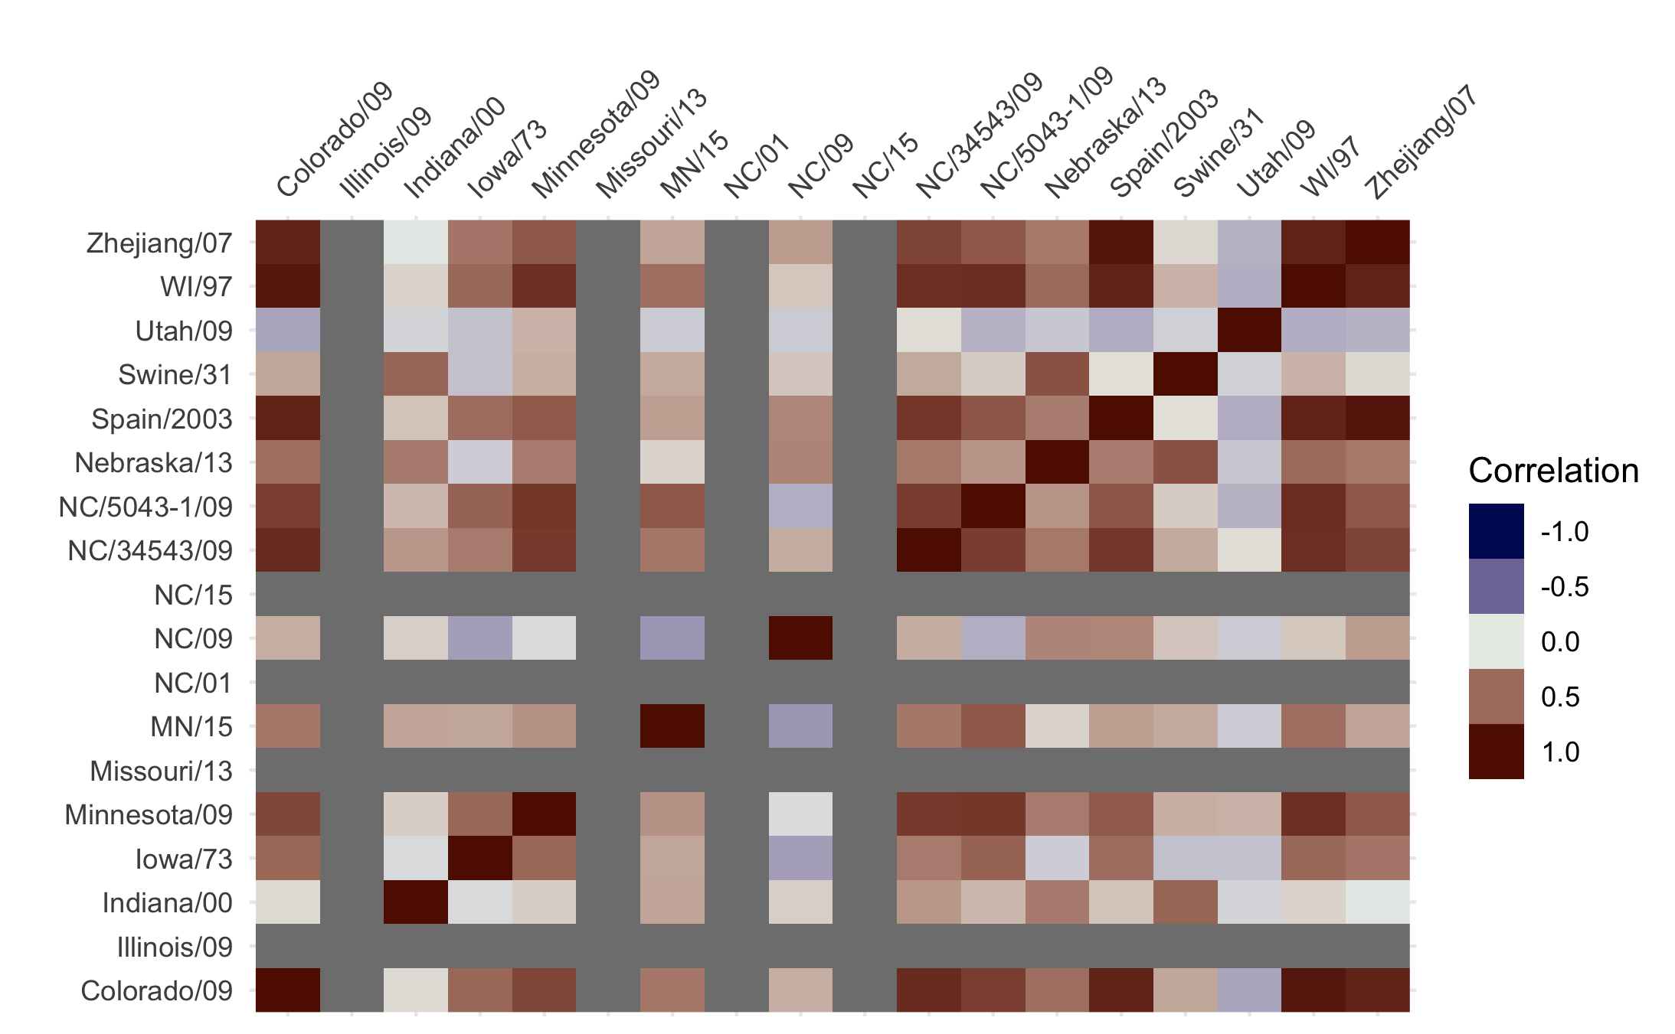

Figure 15: Figure 13. Correlation matix of the inhibitory concentrations of the swine influenza viruses.

### Single Predictor Model

In order to determine if the minimum inhibitory concentration can determine the origin of the antibody a single preditor model was intially used. As a comparitor, the null model returns an ACC of 0.6 for the prediction of CA/09 (the most abundant outcome, compared to the other of P1).

The single predictor model does not fair better than the null model (Table 7). Only one of the single predictor models have a higher accuracy than the null. The NC/09 HA was the model with greater accuracy of 0.833.

|  |  |
| --- | --- |
| variable | Accuracy |
| Spain/2003 | 0.4866667 |
| Zhejiang/07 | 0.4800000 |
| Swine/31 | 0.5200000 |
| Illinois/09 | 0.6000000 |
| Minnesota/09 | 0.5466667 |
| Nebraska/13 | 0.5133333 |
| Iowa/73 | 0.4466667 |
| WI/97 | 0.4733333 |
| Colorado/09 | 0.5333333 |
| NC/34543/09 | 0.4733333 |
| MN/15 | 0.5600000 |
| Utah/09 | 0.6000000 |
| NC/09 | 0.8333333 |
| Missouri/13 | 0.5600000 |
| NC/15 | 0.5800000 |
| Indiana/00 | 0.5333333 |
| NC/01 | 0.6000000 |
| NC/5043-1/09 | 0.5266667 |

When a full logistic model was ran with all of the predictors the accuracy was still equivalent to 0.6 (supplementary table 1). The subset modeling (with 100 iterations) returned some models with higher accuracy (Table 8). The methods in decreasing accuracy were the GA > SFFS = SFS > SBS > SFBS. The NC/09 virus was included in all of the different models. They were all greater than the full and null model of 0.6.

|  |  |  |
| --- | --- | --- |
| method | Accuracy | Model |
| sbs | 0.7933333 | spain_03, mn_09, ne_13, ia_73, wi_97, ut_09, nc_09, nc_5043_09 |
| sfbs | 0.7866667 | spain_03, mn_09, ia_73, wi_97, ut_09, nc_09, in_09 |
| sfs | 0.8333333 | nc_09 |
| sffs | 0.8333333 | spain_03, nc_09 |
| GA | 0.8400000 | swine_31, il_09, ne_13, co_09, ut_09, nc_09, nc_5043_09 |

## Full analysis

### Tree Analysis

The previous analysis only looked at the titers of the monoclonals and did not include any of the other varibles. Inclusion of these other variables may be informative. The other variables were compared to the outcome variables of which virus the monoclonals were raised against (Figure 14). All of the different variables are visualized in Supplemental Figure 9.

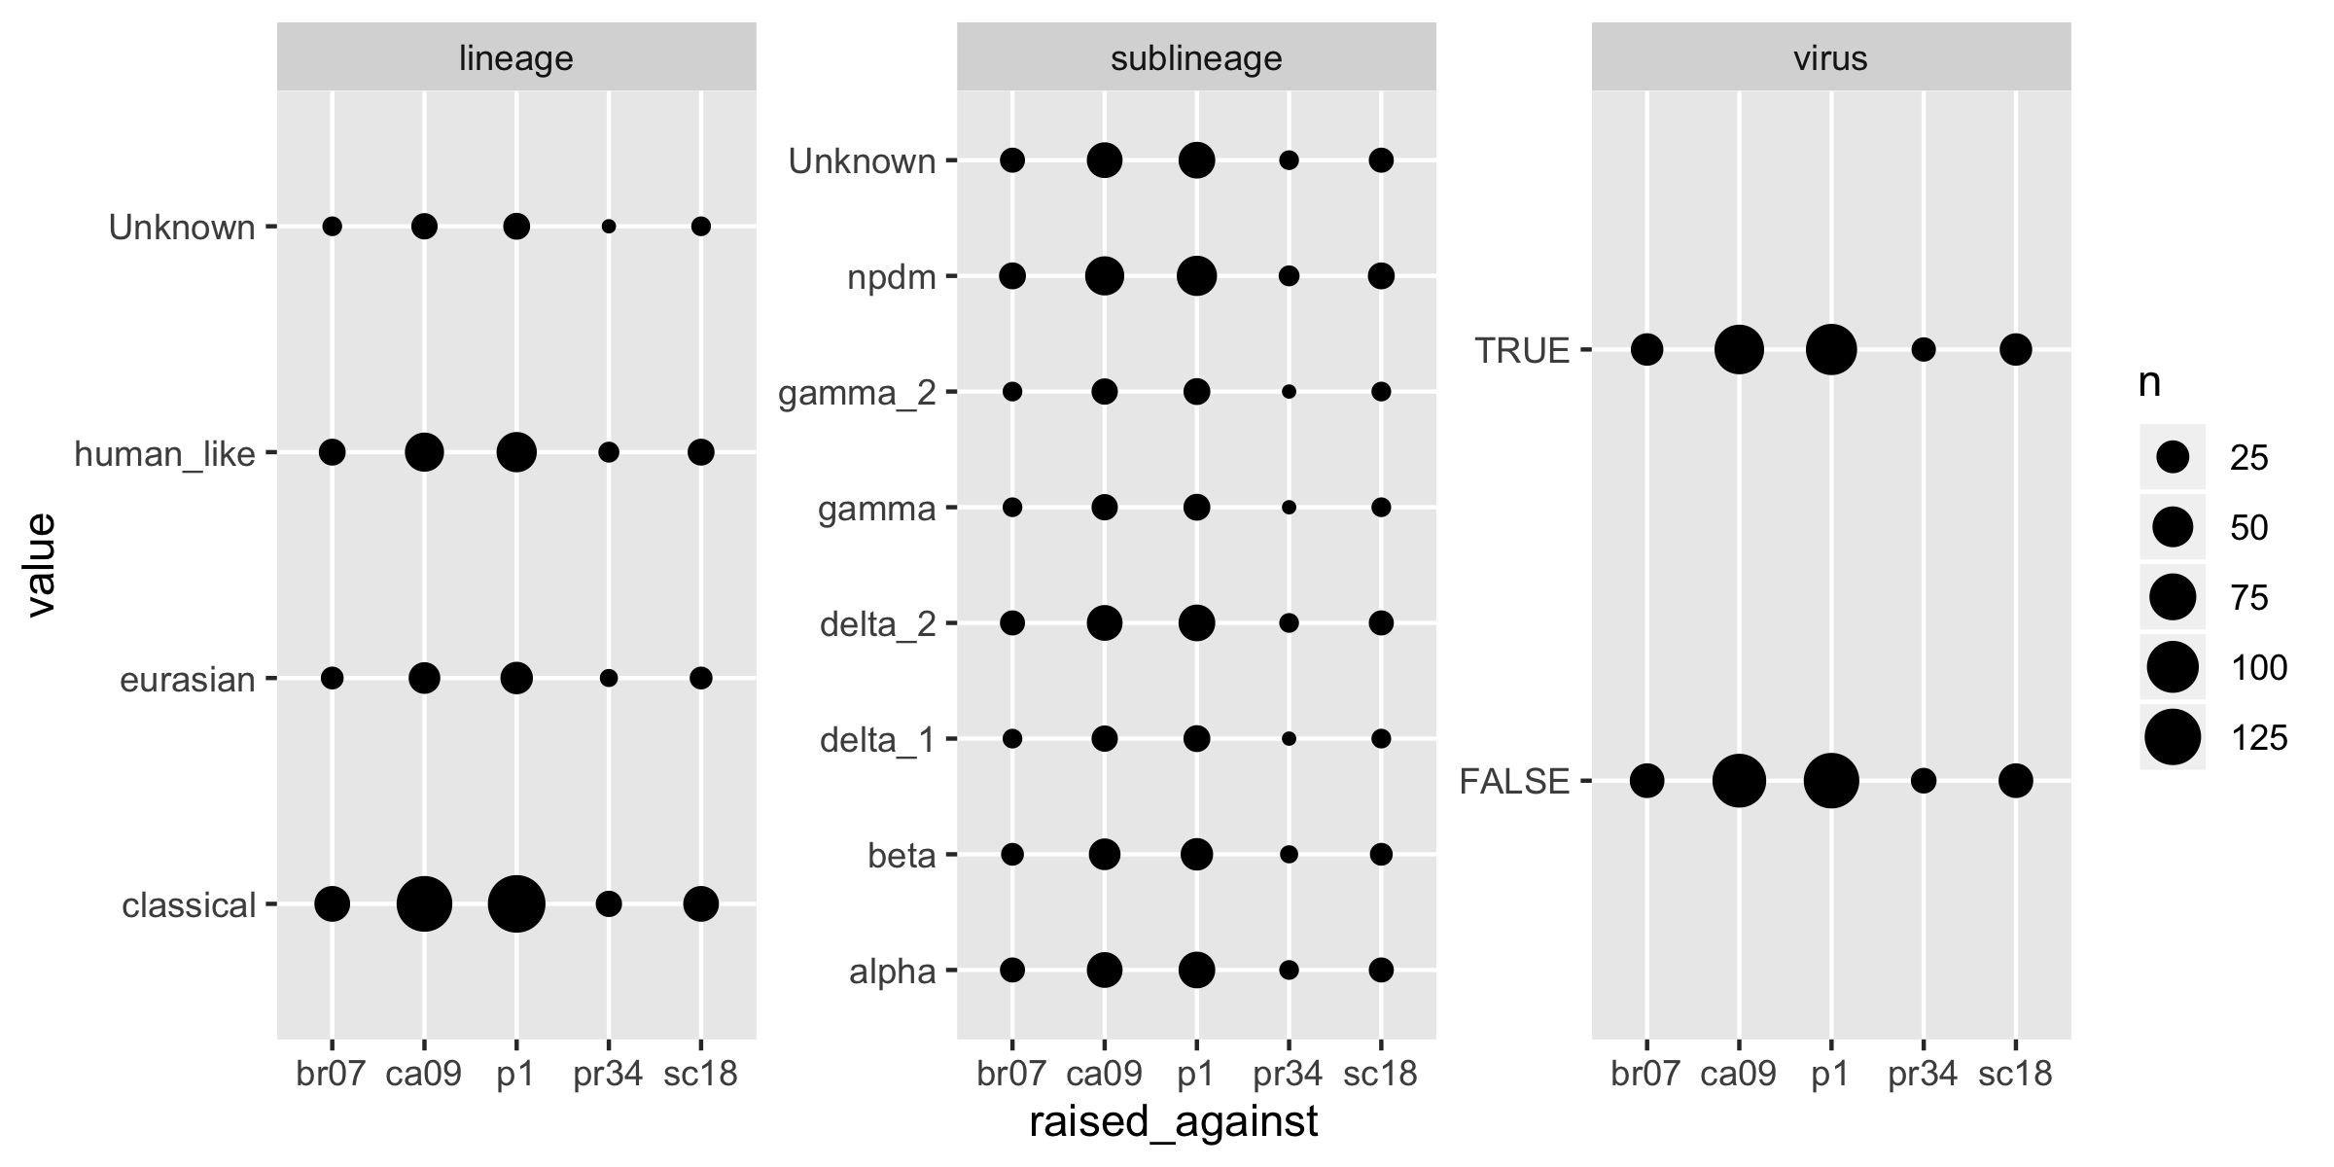

Figure 16: Figure 14. Discrete variables included in the tree analysis. Only variables that had values for all types of raised-against monoclonals were included.

The null model accuracy of predicting P1 (the greatest value) is 0.4 (216/540 total observations). The results of a single predictor analysis is described in Table 9. Three of the seven variables (concentration, log2, and dilution) had a marginally higher accuracy of 0.44 compared to the null of 0.4. These three variables are essentially the same because they are transformations of each other.

## Variable Accuracy  
## 1 concentration 0.4462823  
## 2 log2 0.4402666  
## 3 dilution 0.4466831  
## 4 virus 0.4000262  
## 5 na_sub 0.3907407  
## 6 lineage 0.3753044  
## 7 sublineage 0.3400843

This is not a binomial outcome because there are five different outcomes. Therefore, a decision tree was created to determine if from all of these different variables, if what the antibody was raised against could be predicted. Using all of the variables the tree was poorly structured (Figure 15). 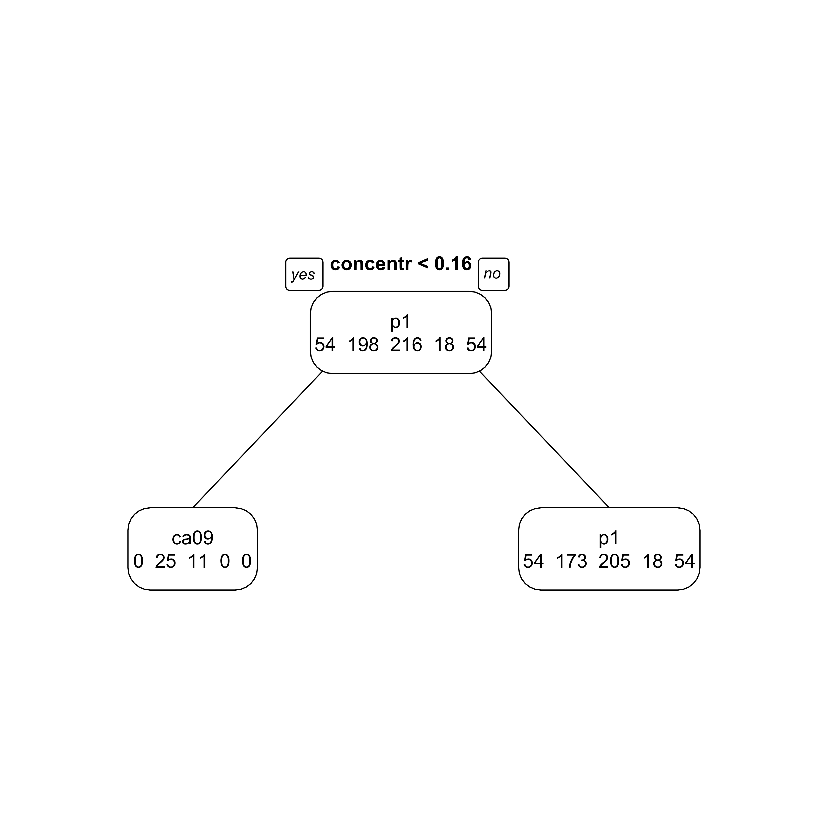 The resulting tree is not informative. Therefore, not enough data is present to provide a decision tree. More variables such as virus neutralizing titer, end-point ELISA binding titers, and in-vivo protection data can be determined and added to the analysis to make it more robust.

### Principal component analysis

The varitation between the monoclonal antibodies was visualized through a principal component analysis (PCA). The variation was reduced to two dimensions. The 45% of the variation was explained through the first component and 15% from the second component (Figure 16). The CA/09 and P1 monoclonal antibodies do not cluster within themselves. The SC/18 antibodies clustered together however. There was some overlap of the points at around (2.5, 0). 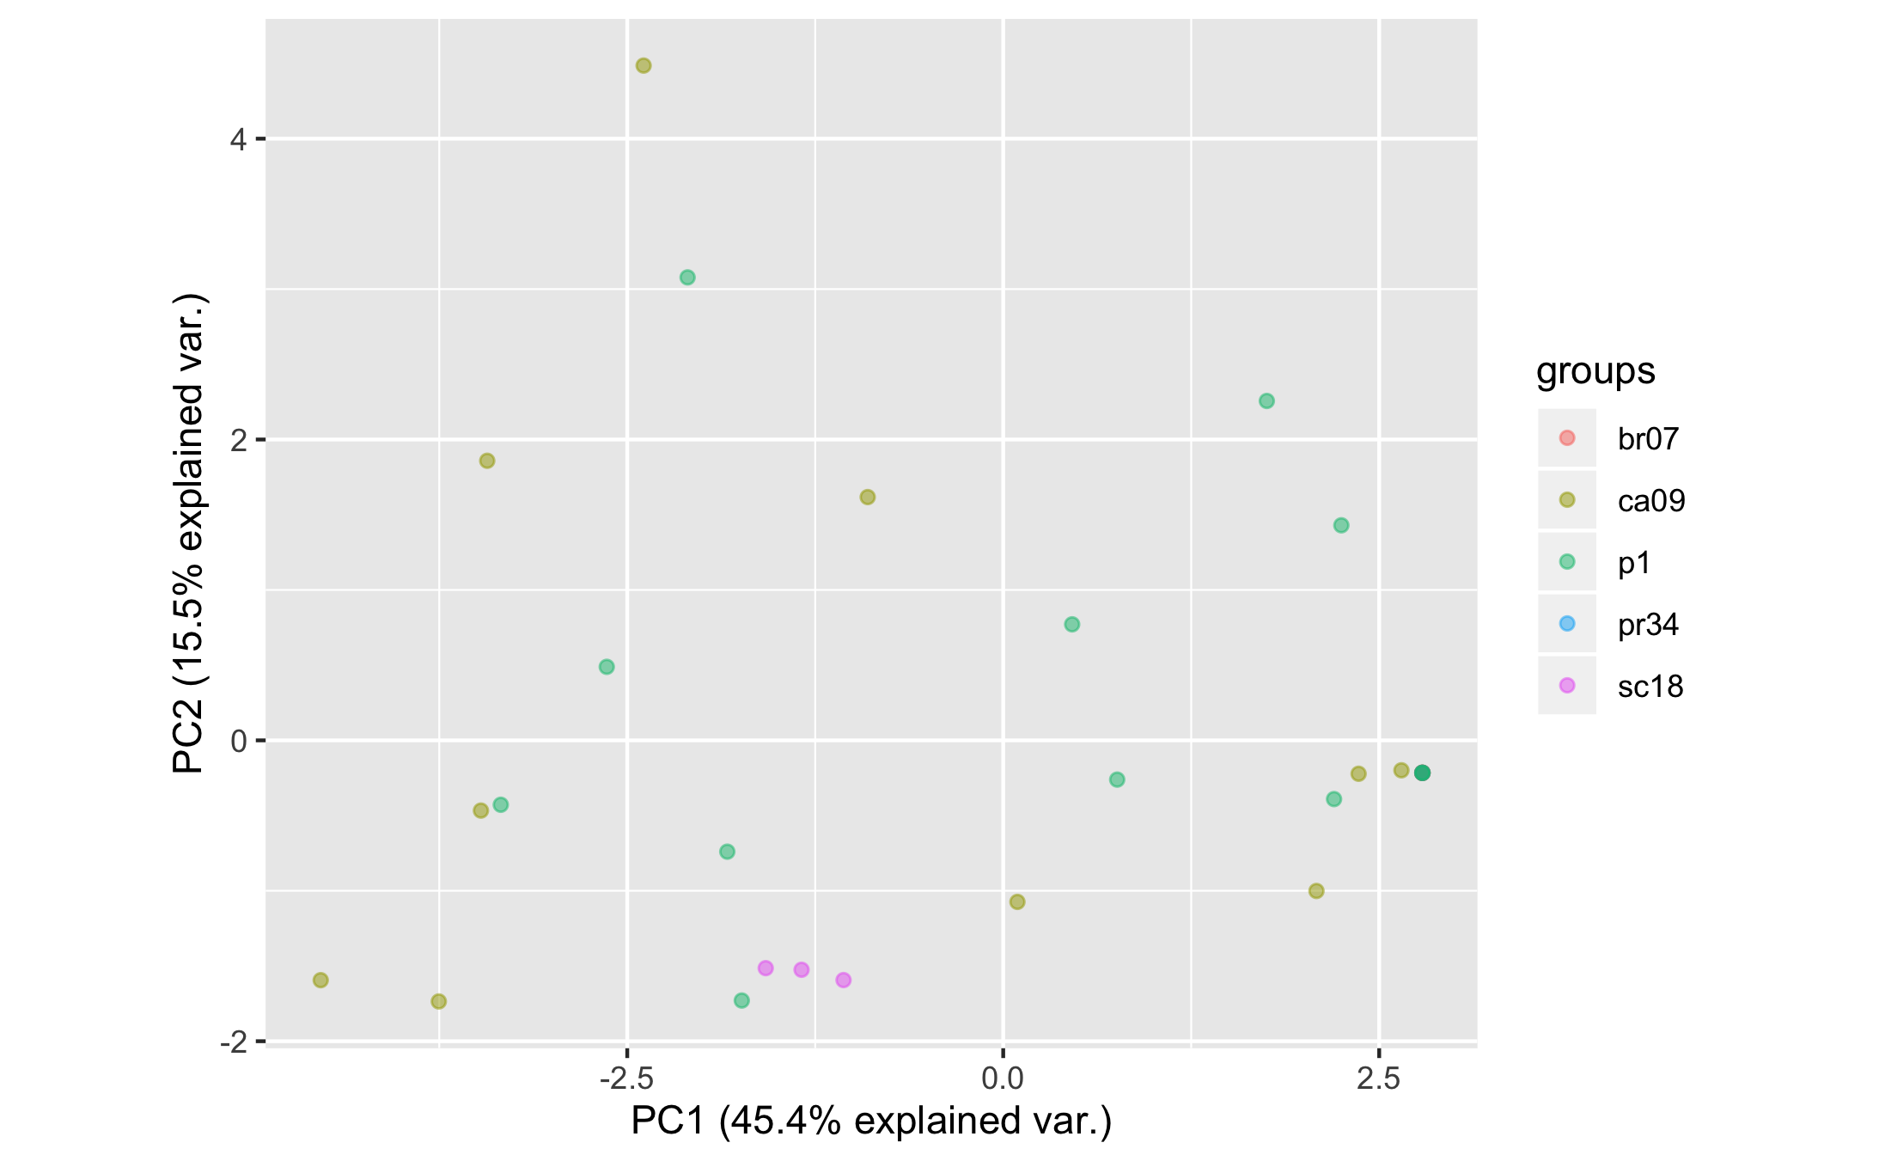 Therefore, the PCA is also not very informative of differences between the two groups. The PCA of the sera responses were also determined (Supplementary figure 6).

# Discussion

## Summary and Interpretation

Similarly, as previously described, COBRA P1-specific mAbs featured a differentiating breadth of HAI activity, spanning from narrowly to broadly reactive mAbs against H1N1 and H1N2 swine viruses. However, contrarily, mAbs endowed with a broad HAI activity against a panel of human H1N1 viruses, featured a narrower HAI profile against swine viruses. Comparatively, those endowed with a narrower HAI activity against human viruses, featured a broader HAI profile against swine viruses belonging to the Eurasian, classical, and human seasonal-like lineages.

Unsurprisingly due to its swine origin, CA/09-specific mAbs, previously classified to have a narrow profile of neutralization activity against pandemic and pandemic-like viruses, exhibited broad HAI activity against swine viruses belonging to all three of the lineages as well.

Interestingly, a class of P1-specific mAbs previously demonstrated HAI activity only against the P1 virus and none of the human H1N1 strains, showed detectable HAI activity against some H1N1 and H1N2 swine viruses, suggesting their HA recognition epitopes are particular to swine viruses and not present in pandemic and pandemic-like HA proteins.

## Strengths and Limitations

The quantity of CA/09- and P1-specific monoclonal antibodies was sufficient for analysis and comparison. But they were both elicited against swine-specific epitopes because CA/09 is a swine-origin human-pandemic virus and P1 was designed by mixing human and swine HA sequences together. There for they both had positive HAI responses against swine viruses. Overall this made them difficult to distinguish from each other. Therefore, the outgroup, or the negative control monoclonal antibodies that were raised against human-seasonal viruses (i.e. A/Brisbane/59/2007) should be expanded to provide more context and comparitors. Inclusion of more human-seasonal monoclonals, their matching viruses and the corresponding HAI titers would improve the principal component analysis by introducing variation into monoclonals that had no reactivity to the swine viruses

Another strength of the analysis is that the virus panel has at least one representative strain from each lineage for the polyclonal sera and at least dupicates for the monoclonal titers. However, in order to distinguish if there were differences between the inhibtion of different virus lineages a higher quantity per lineage will need to be included.

One of the swine viruses A/swine/NC/5043-1/2009 is classified as being a human-seasonal like swine virus but much of the analysis grouped this virus in with the classical swine lineage to the point where it is worrisome. The HA sequence used to generate the virus-like particles and the classficiation of the virus with the literature were checked and it confirmed that the virus was in the human seasonal-like lineage. Therefore one of the limitations may be the the potential for mixing of the lineages and thus muddling of the results.

## Conclusions

The P1 COBRA immunogen elicits a broadly-reactive antibody response to viruses included in it’s design. This result is futher evidence to explain the broadly reactive nature of the CORBA antigens.

Further investigation aimed at determining the amino acid contact residues of these mAbs will improve the resolution of the recognized epitopes, clarify distinctions between human and swine specific H1 epitopes, and elucidate the mechanism of breadth conferred by COBRA immunogens.

# References

Anderson, T. K., Campbell, B. A., Nelson, M. I., Lewis, N. S., Janas-Martindale, A., Killian, M. L., & Vincent, A. L. (2015). Characterization of co-circulating swine influenza A viruses in North America and the identification of a novel H1 genetic clade with antigenic significance. *Virus Res*, *201*, 24–31. <https://doi.org/10.1016/j.virusres.2015.02.009>

Anderson, T. K., Macken, C. A., Lewis, N. S., Scheuermann, R. H., Van Reeth, K., Brown, I. H., … Vincent, A. L. (2016). A Phylogeny-Based Global Nomenclature System and Automated Annotation Tool for H1 Hemagglutinin Genes from Swine Influenza A Viruses. *mSphere*, *1*(6). <https://doi.org/10.1128/mSphere.00275-16>

Anderson, T. K., Nelson, M. I., Kitikoon, P., Swenson, S. L., Korslund, J. A., & Vincent, A. L. (2013). Population dynamics of co-circulating swine influenza A viruses in the United States from 2009 to 2012. *Influenza and Other Respiratory Viruses*, *7*(S4), 42–51.

Skarlupka, A. L., Owino, S. O., Suzuki-Williams, L. P., Crevar, C. J., Carter, D. M., & Ross, T. M. (2019). Computationally Optimized Broadly Reactive Vaccine Based Upon Swine H1N1 Influenza Hemagglutinin Sequences Protects against both Swine and Human Isolated Viruses. *Hum Vaccin Immunother*. <https://doi.org/10.1080/21645515.2019.1653743>